**HFSS ANTENNA TO KICAD COMPONENT**

Author: Tran Quang Khai NGUYEN

L.E.A.T – Sophia Antipolis, 06/11/2018

Version 1

* Included in this file is a process to convert HFSS design to be a component in KiCad. This way, antenna designer can directly work with circuit, hence it removes the dependence on the works of other engineers. It could be very useful because, for *now*, there is no free tool to do it officially. These steps following is a simple example, other complex may not be ensured. Exceptions have been found. Contact author for more details. This is a tutorial on a process which has been discussed long before on the Internet, I try to verify and clarify all step.

***Step 1:*** Export Gerber View (*.ger) file from HFSS. This step comprises some small tasks, which can be done all in HFSS. The antenna is as following:



Go to *Modeler -> Export* to AutoCAD DXF files

Import again to HFSS, *File -> Import -> AutoCAD*

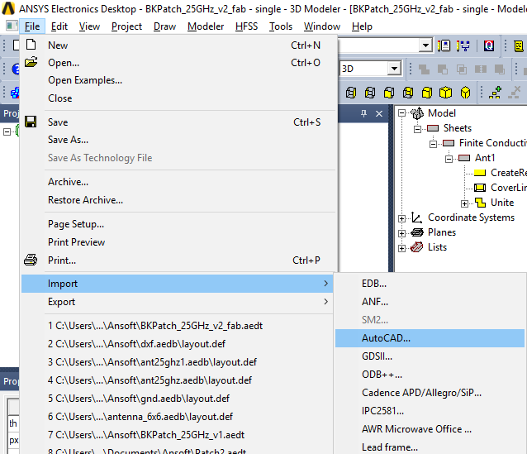

Whatever appears after, click OK. You will have a border-design like the figure following

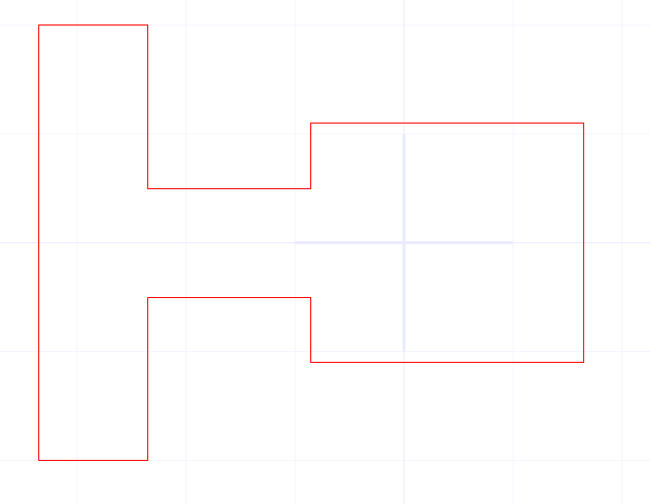

Then, export again to Gerber View file, *File -> Export -> Gerber*

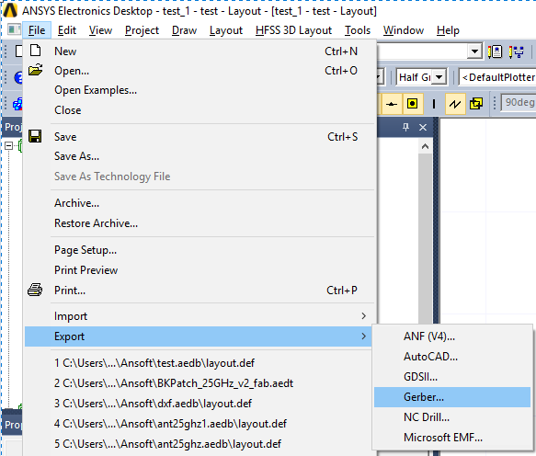

Maybe here you should choose *mm,* by default it can be *in.*  Then click OK

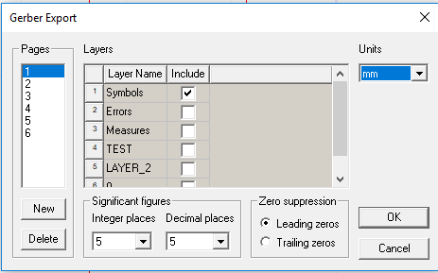

Usually, after this step, the design can be sent to fabrication. But if you need to integrate a circuit? Anyway, that’s the purpose of this file.

***Step 2:*** Transform Gerber View file to PDF file using [Gerber2pdf](https://sourceforge.net/projects/gerber2pdf/) tool. I found it on the internet. It’s a simple and useful tool, you don’t have to install it, in other words, it’s portable.



After Step 1, you might have a list of files, choose the one (the layout) containing you design, others might be useless. Right clight and open it with Gerber2pdf tool. Then you have the pdf file in the same folder.

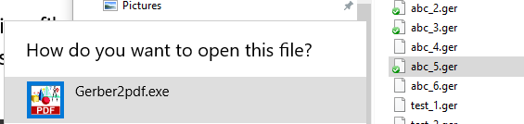

At this step, you have another file, pdf file with black-white image like this:



***Step 3:*** Transform PDF file to Bitmap (*.png) using Inscape. What is Inscape, I don’t know exactly, but I know it can transform PDF to Bitmap, that’s what we need now. Import PDF file from Step 2 to Inscape, *File -> Import*. I suggest to use high *gradient meshes:*

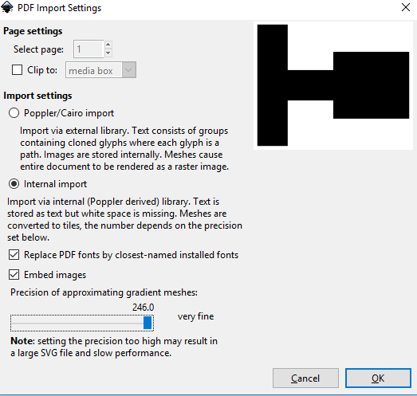

Go to *File -> Document Properties*, in tab *Page*, click *Background Color*, in tab *RBG*, change *A* to 255, close.

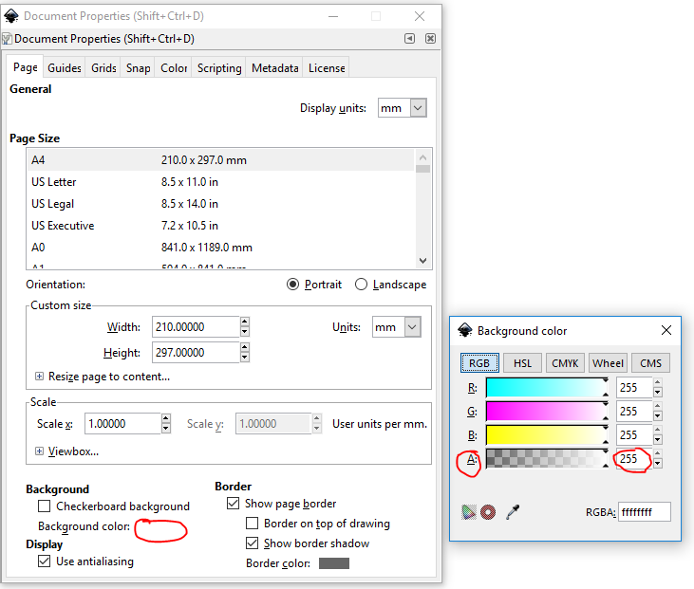

Then, increase image size. The larger is the size, the longer time is required to convert and export/import. In fact I prefer more than 1000 dpi.

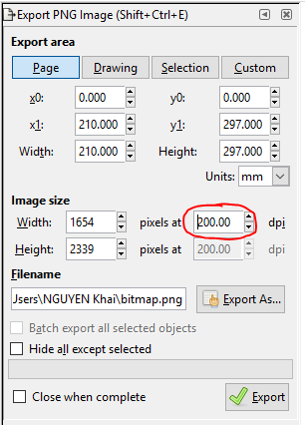

Choose destination folder in the window above at *Export As*, and click *Export*. Now you have a Bitmap file!!

***Step 4:*** Finally, on KiCad, transform Bitmap to components file (*.kicad_mod). Open *Bitmap to Component Converter*. Load the Bitmap file and export to *Pcbnew*.

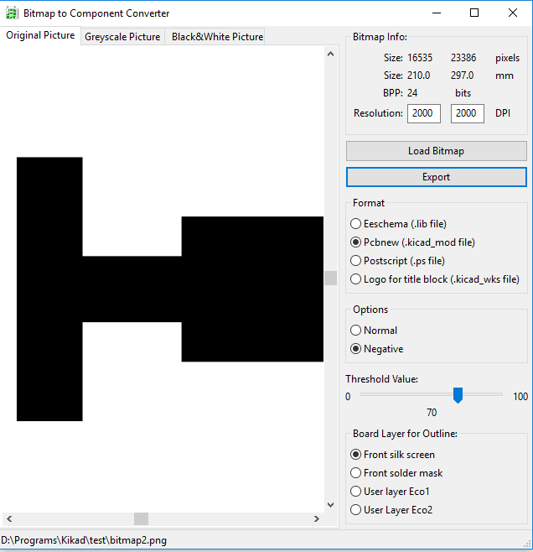

Hopefully, you will have no error and get the component file!!

Other part of the work including import, modify and save components can be found on the internet, it doesn’t not belong to the scope of this document. I succeeded to make this simple board with just antenna and connector:

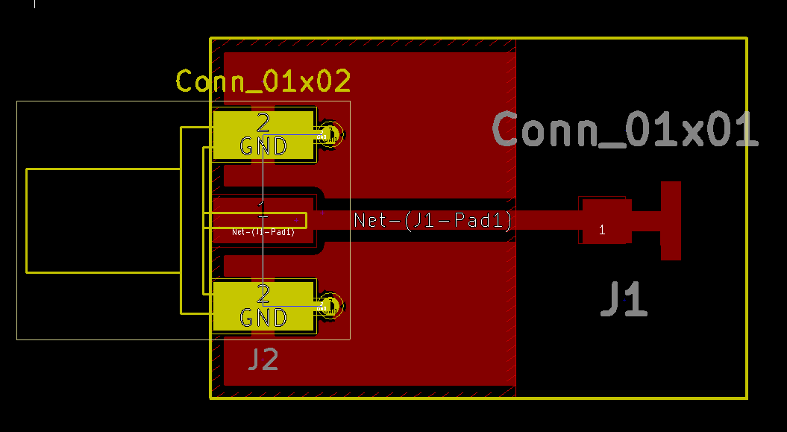

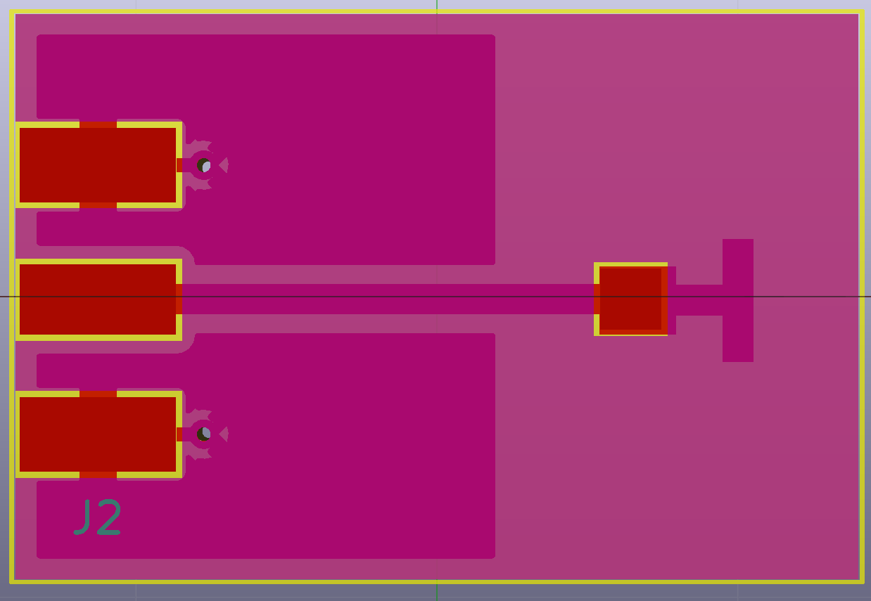

* Note: this conversion might change the scale of design, I expect it depends on resolution applying on Inscape.
* Anyway, it’s a long way to go, but it works, and is free! Hope you enjoy! 😊